**Virtual table**

Содержание

Remote Data Source -> Virtual Table

Virtual table and Open ODS View

# CDS View accessing external system remotely in S/4HANA

**Remote Data Source -> Virtual Table**

<https://tmilinovic.wordpress.com/2019/03/17/sap-hana-data-integration/>

Содержание

**Data Federation**

It’s a form of data virtualization where the data stored in a heterogeneous set of autonomous data stores is made accessible to data consumers as one integrated data store by using on-demand data integration. *No moving or replication of data is needed* since all data stays in the source systems.

**SAP HANA Smart Data Access - SDA**

SDA provides a real-time access to data located outside of the SAP HANA database, without having to replicate the data to SAP HANA ⇒ **it’s a data federation tool**.

Virtual table can be manipulated by SAP HANA just like an ordinary table.

**SAP Smart Data Integration - SDI**

**SDI = Data Federation /broader adapter support than in SDA/ + Data Consolidation**.

SDI is part of the Enterprise Information Management - EIM module and is integrated with Hana Monitoring Cockpit.

SDI Components

* *HANA Data Provisioning Server* – a ***dpserver*** process inside HANA platform. When SAP HANA is first installed, the Data Provisioning Server is disabled. Enabling the Data Provisioning Server gives you the ability to use SDI [*not needed for SDA*].
* *Data Provisioning Agent* – is a separately installed container running outside the SAP HANA environment, and it is managed by the Data Provisioning Server. It provides connectivity for all those sources where the driver cannot run inside the Data Provisioning Server. Through the Data Provisioning Agent, the preinstalled Data Provisioning Adapters communicate with the Data Provisioning Server.

DDL changes from remote sources are propagated to SAP HANA in real time.

**An Example of SAP HANA – MS SQL Server Data Federation**

I am using SAP HANA Smart Data Access - SDA and the whole procedure is totally easy

1. Download, install and configure SQL Server ODBC Driver
2. Create MSSQL ***remote source***

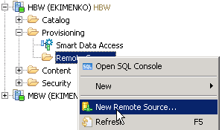

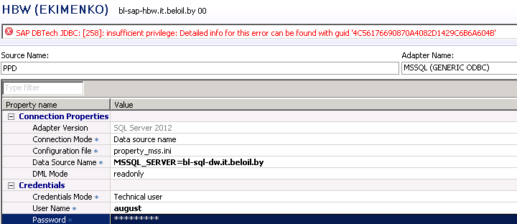

SAP DBTech JDBC: [258]: *insufficient privilege*- Detailed info for this error can be found with guid '4C56176690870A4082D1429C6B6A604B'

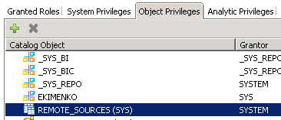

1. Create ***virtual table***

**Virtual table and Open ODS View**

Содержание

# *How to Use Open ODS Views*

***Open ODS View*** - is a virtual data model that allows you to define data models for objects like *database tables*, *database views* or *DataSources* without the need to create InfoObjects.

## ***What are Open ODS Views?***

Open ODS Views enable to consume, combine and physically integrate data from various sources in SAP BW/4HANA without staging. These data models allow you to access external data sources without the need to create InfoObjects, which can save time and effort in data modeling.

Open ODS Views consist of two main components

* ***Source*** - provides the data for the Open ODS View. The source can be a database *table*, a database *view*, a SAP HANA *Calculation View*, or a *DataSource* [for direct access].
* ***Output Structure*** - defines the fields and semantics of the Open ODS View. The output structure can have key fields or data fields, and they can have different attributes, such as data type, length, aggregation type, etc.

## ***What types of sources are supported?***

The following source types are supported

* ***Database Table or View*** - allows to access data from any schemas on the SAP BW/4HANA SAP HANA database1. The connection to the relevant schema is configured in the SAP HANA source system with connection type Local SAP HANA Database Schema.
* ***SAP HANA View*** - allows to access data from SAP HANA *Calculation Views* that are located in any schemas on the SAP BW/4HANA SAP HANA database1.
* ***SAP HANA Smart Data Access*** - allows to access data from any databases that can be connected to the SAP BW/4HANA SAP HANA database using SAP HANA Smart Data Access. The connection to the relevant database is configured in the SAP HANA source system with connection type *Remote Source*.
* ***Transformation*** - allows to apply transformations on data that is consumed using Open ODS Views. You can use this source type to perform data type conversions or string operations on data, for example. You need to specify a DataSource as the source and an InfoSource as the target for this source type.
* ***DataSource [for direct access]*** - allows to access data from DataSources that are located in any systems that can be connected to SAP BW/4HANA using Operational Data Provisioning - *ODP*. The connection to the relevant system is configured in the ODP source system with connection type ODP Context.

1 - The connection to the relevant schema is configured in the SAP HANA source system with connection type Local SAP HANA Database Schema.

## ***How to create and activate Open ODS Views?***

The steps are as follows

1. In the Project Explorer, right-click on the InfoArea where you want to create the Open ODS View and choose ***New -> Open ODS View***.
2. In the wizard, enter a technical name, a description, and a source type for the Open ODS View. Click ***Next***.
3. In the next screen, you can select or create the source for the Open ODS View. Depending on the source type that you chose, you will see different options for selecting or creating the source. Click ***Finish***.
4. The Open ODS View is created in the inactive version and is displayed in the editor. You can make further changes to the Open ODS View properties, such as output structure, semantics, filters, etc.
5. To activate the Open ODS View, right-click on the Open ODS View and choose ***Activate***.

## ***How to use Open ODS Views in data flows or mixed modeling scenarios?***

Open ODS Views can be used

* *to access data from external sources* without the need to create InfoObjects or persist the data in SAP BW/4HANA. You can use these Open ODS Views for reporting and analysis, or as part providers for Composite Providers.
* *to combine data from external sources* with data from SAP BW/4HANA models. You can use links to InfoObjects to access master data attributes and texts in SAP BW/4HANA, or you can use Composite Providers to join or union data from different sources.
* *to physically integrate data from external sources* into SAP BW/4HANA. You can *create DataSources for Open ODS Views* and load the data into ADSOs or InfoCubes, for example.

Here is an example of a data flow that uses Open ODS Views to consume, combine and physically integrate data from different sources.

In this example, the following steps are performed

1. An Open ODS View *SALESORG1*)is created with source type *Database Table* | *View* to access a database table that contains sales organization master data.
2. An Open ODS View *SALESPERSON* is created with source type SAP HANA View to access a SAP HANA *Calculation View* that contains sales person master data.
3. An Open ODS View *SALES* is created with source type *DataSource [for direct access]* to access a DataSource that contains sales transaction data from an external system.
4. A *Composite Provider* *SALESJOIN* is created with type based on Join to join the three Open ODS Views by *country* and sales *organization* fields. The Composite Provider also uses links to InfoObjects to access currency and unit conversion factors from SAP BW/4HANA.
5. A DataSource *SALESJOIN_DS* is created for the Composite Provider SALESJOIN to physically integrate the joined data into SAP BW/4HANA.
6. A Data Transfer Process (DTP) is created to load the data from the DataSource SALESJOIN_DS into an ADSO *SALESCUBE* that stores the sales transaction data in SAP BW/4HANA.

## Open ODS View *SALESORG1* Composite Provider *SALESJOIN*

*Database Table SALESORG1.country = SALESPERSON.country*

*SALESORG1.organization = SALESPERSON.organization*

Open ODS View *SALESPERSON SALES.country = SALESPERSON.country*

*Calculation View SALES. organization = SALESPERSON.organization*

An Open ODS View *SALES*

*DataSource [for direct access]*

## DataSource *SALESJOIN_DS* ->ADSO *SALESCUBE*

# CDS View accessing external system remotely in S/4HANA

<https://blogs.sap.com/2021/10/23/cds-view-accessing-external-system-remotely-in-s-4hana/>

Содержание

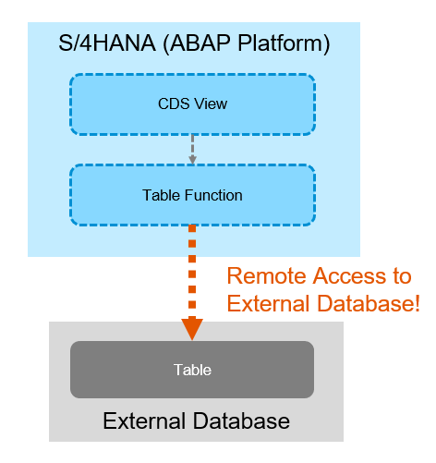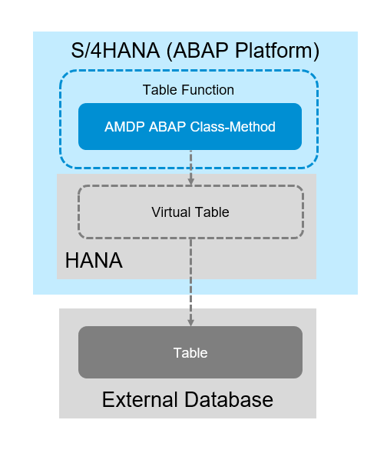

**How can the Virtual Table be created?**

Thanks to the program “ZICA_CREATE_VIRTUAL_TABLE” in [the blog “Using Remote Data Source in ICMR”](https://blogs.sap.com/2021/04/07/using-remote-data-source-in-icmr/), Virtual Table can be created in ABAP Layer (so, it is possible with HANA REAB edition).

**Which external sources are available?**

The sources available for HANA SDA are available, e.g. HANA, HANA Cloud, ASE, IQ, Oracle, MSSQL, Google Big Query, etc.. All SDA supported remote sources require installation and configuration of ODBC driver. Details are in [SAP Note 2600176 – SAP HANA Smart Data Access Supported Remote Sources](https://launchpad.support.sap.com/#/notes/2600176),

**SAP EIM – Smart Data Integration (SDI) roles and privileges**

<https://int4.com/sap-eim-smart-data-integration-sdi-roles-and-privileges>